**To solve the exercises, create a document with screenshots including the settings for each part.**

1. Create an empty virtual machine and configure the following settings:
   * For Windows 10 (64 bits, or 32 if you do not have enough RAM in your physical computer).
   * 2GB of RAM memory.
   * Boot order (CD and hard drive).
   * Two hard drives: one with 50 GB for the operating system and another one with 30 GB empty. Select the type of disk that can dynamically increase.

We click “Machine -> New”

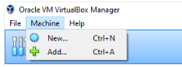

Then, we select the Operating System (OS)

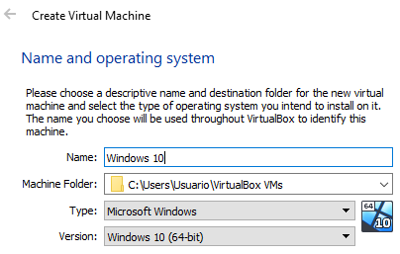

Afterwards, we can select the RAM memory we need (2 GB).

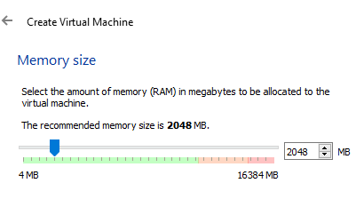

Now we create the first disk for the operating system using type VDI

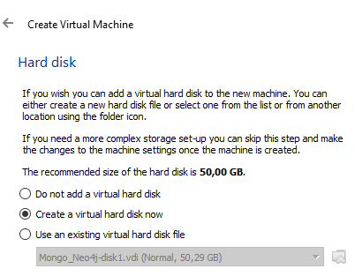

… And “dynamically allocated” in order not to waste storage

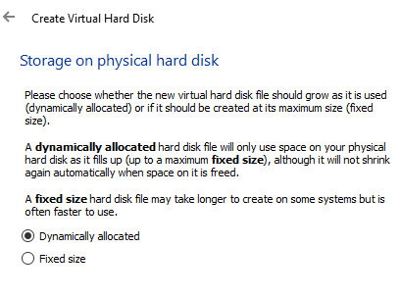

Once created the virtual machines, we can change the boot order from settings like in the screen below (clicking the “System” tab)

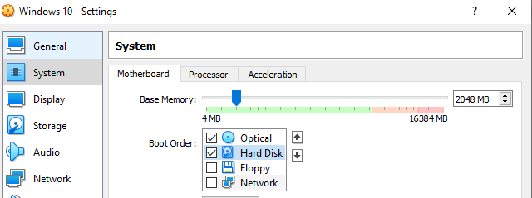

Finally, we create the additional 30 GB disk from “Storage”

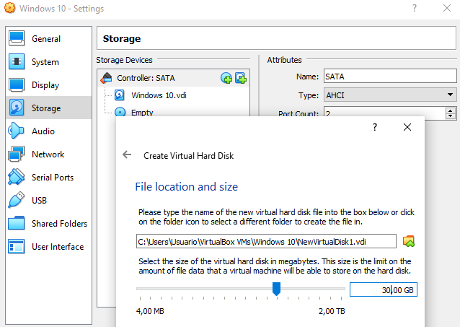

1. Install Windows 10 in the virtual machine from exercise 1. You must add the following settings:
   * USB 3.0 support.
   * Shared folders.
   * Internet connection including access to the rest of computers of the network.
   * You will be able to copy and paste from the host to the guest and vice versa.

To install Windows 10, we need to add the ISO file from the “Storage” tab

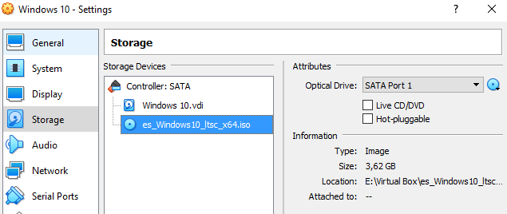

The required “Network” setting to meet the statement criteria is “Bridge adapter”

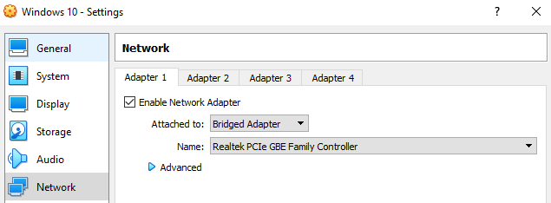

Then, we start the virtual machine and follow the steps from the files “Unit 1. Installation of free and proprietary operating systems” and “Unit 1. Summary of partitions installing Windows and Linux”

Once installed Windows 10, it is necessary to setup “Guest additions” to enable the clipboard and shared folders.

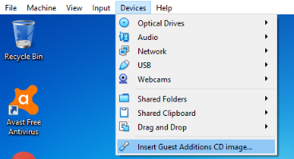

After installed, you can set these tools from the same menu as you can see the picture below, or the virtual machine settings.

For the clipboard, the correct option is “bidirectional”

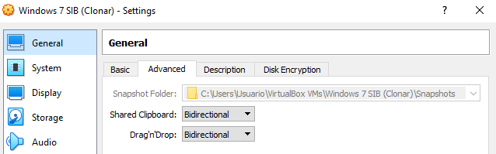

And for the shared folder, you need to select the source directory you want to use from the guest operating system. Using the “Auto-mount” you do not need to configure anything else, at least for a Windows virtual machine

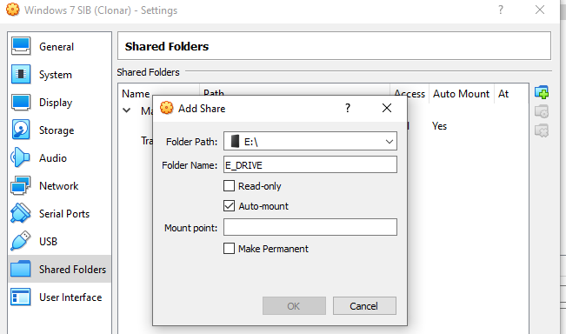

For the USB 3.0, you first need to install an extension from “File -> Preferences” in the VirtualBox main menu

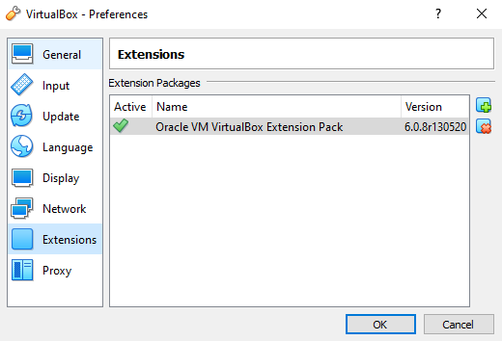

Then, you can add the required USB from the corresponding tab in the virtual machine settings

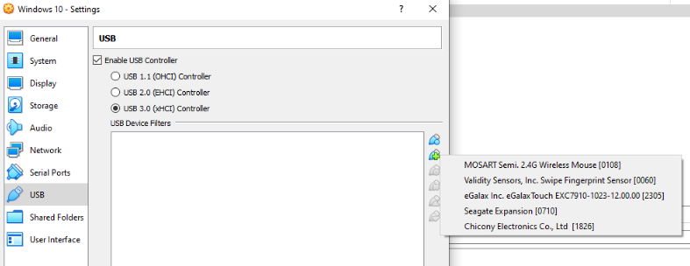

Another option is to “plug and play” when the virtual machine has been started

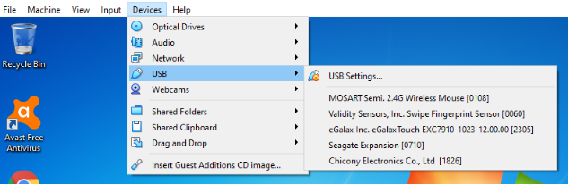

Anyway, for storage devices, it is more recommended to share a folder pointing to the external disk root folder. Using USB from VirtualBox, the device is disconnected from the physical computer and it is only possible to use it from “host or guest” at the same time. Using a shared folder, you can access simultaneously both from “host and guest”

1. Create another 64-bits virtual machine and install Ubuntu 16.04. The virtual machine must meet the following requirements:
   * 2 GB of RAM memory.
   * Just one disk of 30 GB.
   * A shared folder to an external disk.
   * Internet connection.
   * You will be able to copy and paste from the host to the guest and vice versa.

We create the virtual machine using similar settings to exercises 1 and 2, but selecting 64-bits Ubuntu

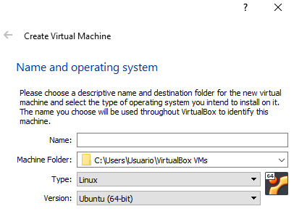

You can also follow the steps from “Unit 1. Installation of free and proprietary operating systems” and “Unit 1. Summary of partitions installing Windows and Linux”. It is especially important to set the number of partitions like in the theory.

We will also need “Guest additions” to enable the clipboard and share folders. Remember: from the “Devices” menu

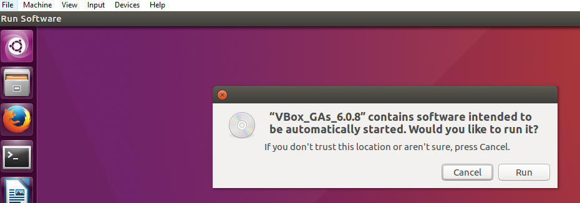

Regarding the share folder, the process is the same as in exercise 2, but you will need similar configurations like the link below.

<https://www.howtogeek.com/187703/how-to-access-folders-on-your-host-machine-from-an-ubuntu-virtual-machine-in-virtualbox/>

In this case we are only required “Internet connection”, so the default “NAT” is valid

